HEART DISEASE PREDICTION

1.Importing all necessary libraries.

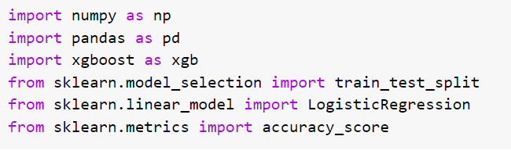

2.loading dataset

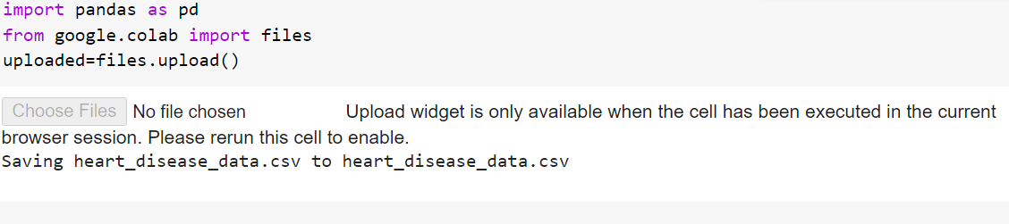

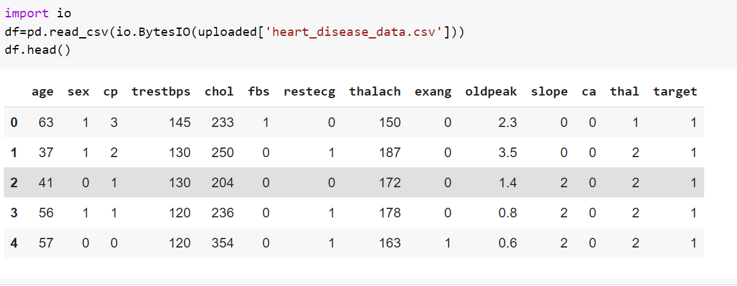

3.retrieving last 5 rows.

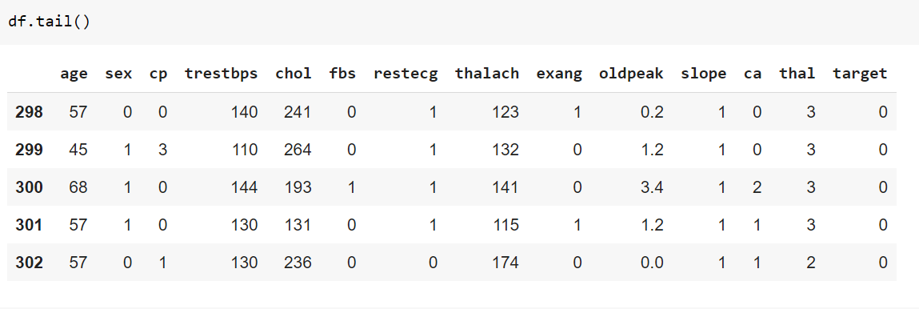

4.retrieving no.of rows and no.of columns of dataset.

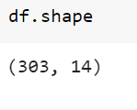

5.retrieving all data columns with data type.

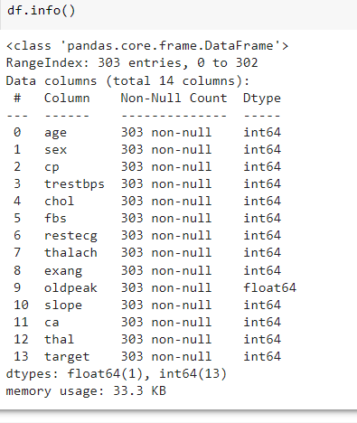

6.checking for missing values.

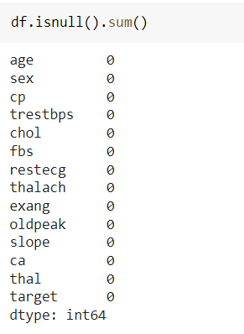

no missing values in dataset.

7.to retrieve statistical values

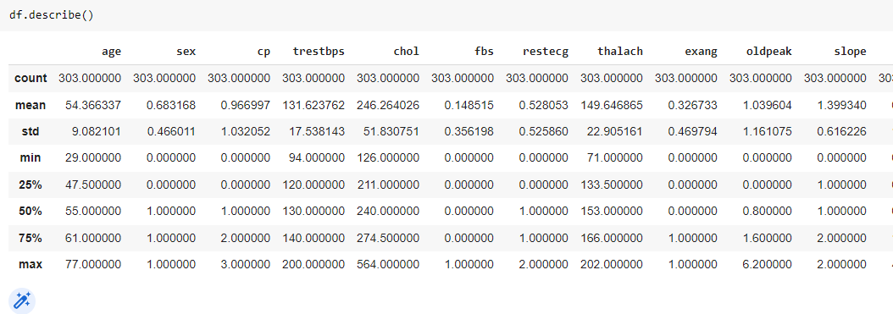

8.to plot histograms



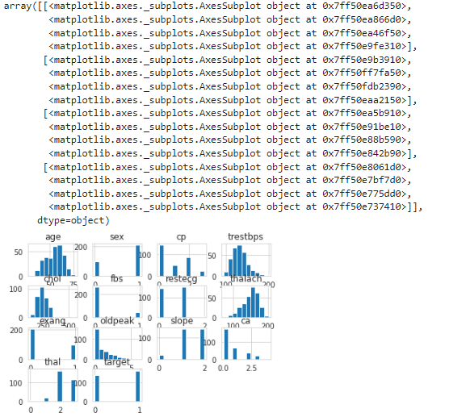

9.calculating the target values.

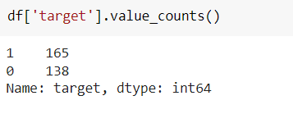

10.splitting the data into feature columns and target column

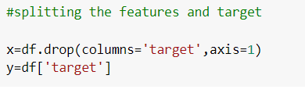

Feature columns are:

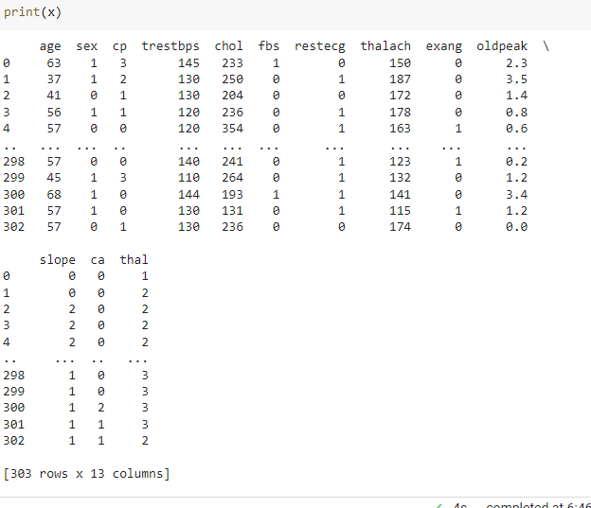

Target column is:

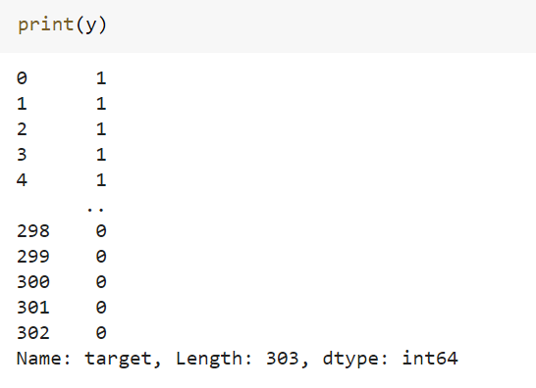

11.splitting the data into training data and testing data.



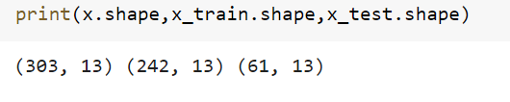

12.training the model using logistic regression.

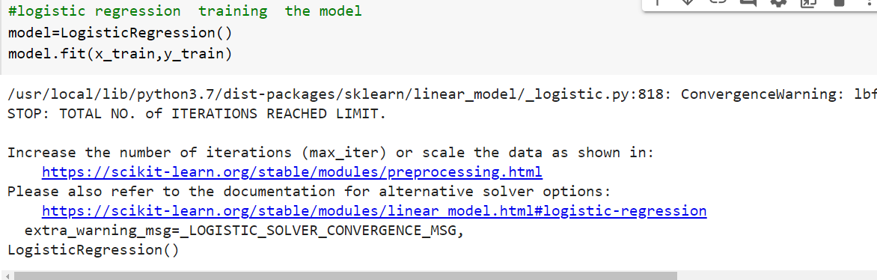

13.calcultaing accuracy on training data.

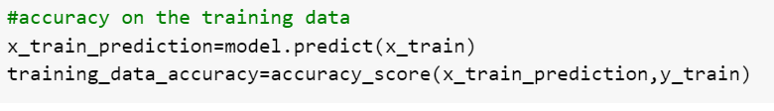

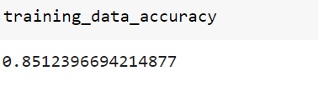

14.calculating accuracy on testing data.

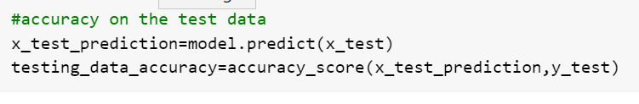

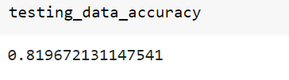

15.predicting if the person have heart disease or not.

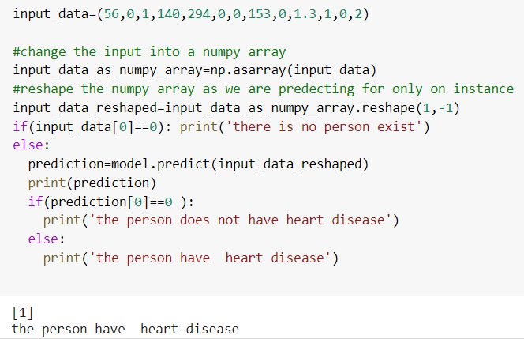

16.training the model using XGBoost classifier.

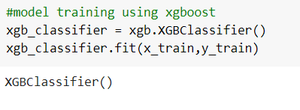

17.calculating the accuracy on traing data

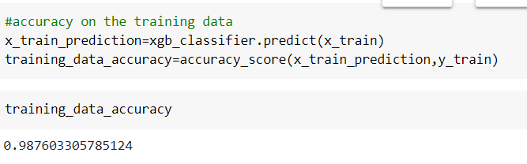

18.calculating the accuracy on testing data

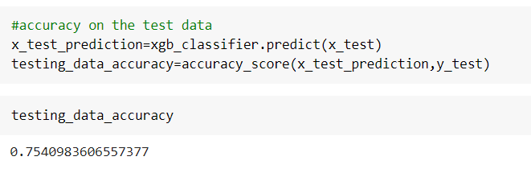

19.predicting if a person has heart disease or not using xgboost.

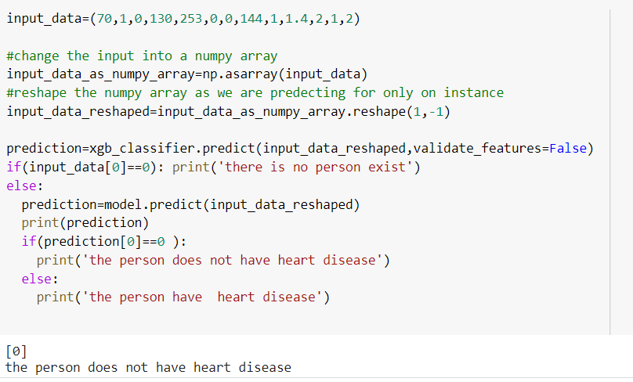

20.what is maximum age of female having heart disease.

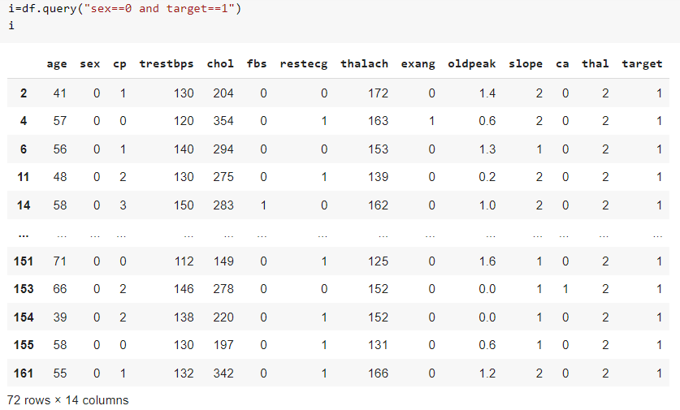

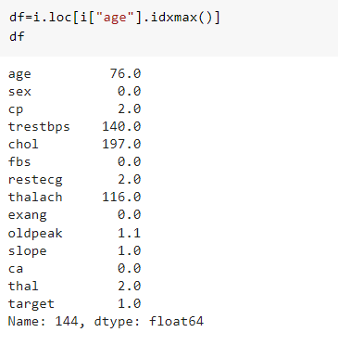

21.what is the minimum age of female having heart disease.

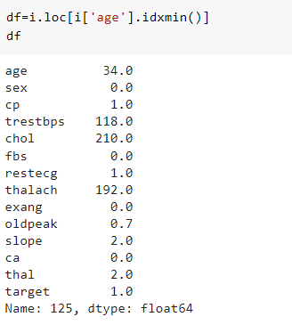

*Prepared by*

*p.swathi*

*s180471*

*cse-3c*